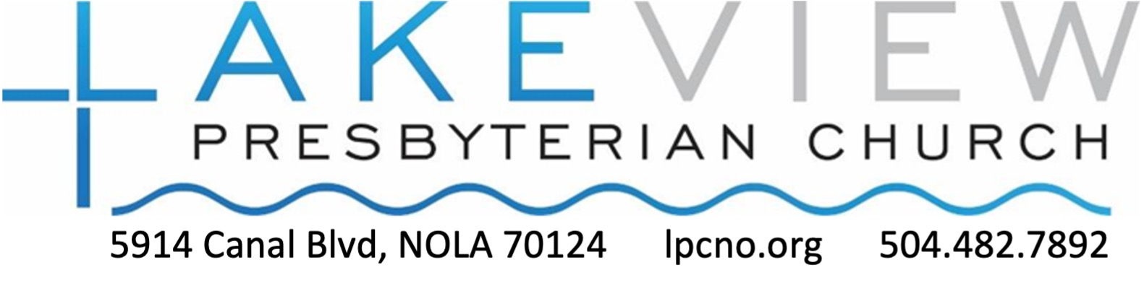

Baptism of the Lord
January 11, 2026
10:30am

GATHER

WORDS OF WELCOME Rev. Alex Lee-Cornell
You are invited to greet those around you and share signs of Christ’s peace.

GATHERING SONG Spirit of the Living God No. 288
Spirit of the living God, fall afresh on me. (x2)
Melt me; mold me; fill me; use me.
Spirit of the living God, fall afresh on me.

*CALL TO WORSHIP based on Psalm 29 Cheryl Farmer, liturgist
The voice of the Lord is powerful and full of majesty.
May the Lord bless us with God’s Peace!
The voice of the Lord proclaimed Jesus as God’s beloved.
In our own baptisms, we are claimed as God’s beloved.

*HYMN OF PRAISE Sing Glory to the Name of God No. 10

CONFESSION AND PARDON
Call to Confession
Prayer of Confession and Assurance of Pardon
Merciful God, we confess that we are estranged from you and from one another.
We treat others as strangers
rather than as people created in your image and fellow children of God.
We exploit the earth as though it were our possession
rather than a gift entrusted to our care and a reflection of your image and glory.
Forgive us our sins, and transform us by your Spirit
that we might live as people who have been baptized as your own children. Amen.

___________________________________
*You are invited to stand.
Please join in saying/singing aloud the responses printed in bold.
Hymn numbers correspond to the pages in the red or purple Glory to God hymn book in the pew rack in front of you.
*Response to Pardon Glory Be to the Father No. 581
Glory be to the Father, and to the Son, and to the Holy Ghost;
as it was in the beginning, is now, and ever shall be,
world without end. Amen, amen.

During the Response to Pardon, the young (and young at heart!) are invited to come forward to sit in the front row of chairs by the piano in preparation for the Time with Children.

PROCLAIM

TIME WITH CHILDREN
Following the Time with Children, young worshipers
may remain in worship or choose to attend Sunday school in the Fellowship Hall.

PRAYER FOR ILLUMINATION

SCRIPTURE READINGS
Gospel Reading Matthew 3:13-17 NRSVue
Holy Wisdom, Holy Word.
Thanks be to God.
Hebrew Bible Reading Isaiah 42:1-9 NRSVue
Holy Wisdom, Holy Word.
Thanks be to God.

MESSAGE One of Us Rev. Alex Lee-Cornell

RESPOND

* HYMN OF RESPONSE We Walk By Faith and Not By Sight No. 817

*AFFIRMATION OF FAITH from Presbyterian Church (USA)’s A Brief Statement of Faith
We trust in God the Holy Spirit, everywhere the giver and renewer of life.
The Spirit justifies us by grace through faith, sets us free to accept ourselves and to love God and neighbor, and binds us together with all believers in the one body of Christ, the Church.
The same Spirit who inspired the prophets and apostles rules our faith and life in Christ through Scripture, engages us through the Word proclaimed, claims us in the waters of baptism, feeds us with the bread of life and the cup of salvation, and calls women and men
to all ministries of the Church.

OPPORTUNITIES TO MINISTER, CONNECT, AND SERVE
- Sign up to serve as a liturgist or Sunday school teacher
- Send a card or make a phone call to someone in special need of love and support.
- Bring donuts or other treats for Sunday fellowship time before and after worship.


OFFERING OUR GIFTS TO GOD
During this time, you are invited to make a financial contribution to LPC. You may do so by placing cash or a check (payable to “LPC”) in the offering plate, or give by credit card by using the QR code to be directed to our online giving page. (Note - this QR code does NOT work in Venmo/Paypal or any other third party app.) You are also encouraged to be in prayer about how you can use your time and talents to serve God and neighbor this week.

PRAYERS OF THANKSGIVING, INTERCESSION AND THE LORD’S PRAYER
…Our Father, who art in heaven, hallowed be thy name. Thy kingdom come, thy will be done on earth as it is in heaven. Give us this day our daily bread, and forgive us our debts as we forgive our debtors; and lead us not into temptation, but deliver us from evil, for thine is the kingdom, and the power, and the glory forever. Amen.
GO
*SENDING HYMN Will You Let Me Be Your Servant No. 727

*CHARGE & BENEDICTION

*POSTLUDE
Following the Postlude, you are invited
to enjoy refreshments, coffee, and conversation in the Fellowship Hall.

Worship may be over, but our service has just begun.

We are glad that you have chosen to worship with us.
Lakeview Presbyterian Church brings God’s word to life
in a welcoming atmosphere of worship, prayer, and fellowship,
while spreading the love of Jesus Christ
through Christian education and outreach, wherein all are welcome.

LAKEVIEW PRESBYTERIAN CHURCH STAFF

Ministers All LPC members
Pastor Rev. Alex Lee-Cornell pastor@lpcno.org
Director of Music Tom Brown
thomasbrown723@gmail.com
Bookkeeper and Office Administrator Lien Tran
office@lpcno.org
Weekday School Co-Directors Angelle Guepet and Mary Clement
lakeviewweekdayschool@gmail.com

When saying the Lord’s Prayer, some prefer to use the words “forgive us our sins as we forgive those who sin against us” or “forgive us our trespasses as we forgive those who trespass against us.” Please pray as you feel led. The Call to Worship, Confession and Pardon, Prayer for Illumination, Prayers of Thanksgiving and Intercession, and Affirmation of Faith were adapted from prayers written by Roger Gench for Presbyterian Outlook. https://pres-outlook.org/2025/12/order-of-worship-january-11-2026/ All music and hymns for this service are from Glory to God, The Presbyterian Hymnal and used with permission. CCLI # 21252663; One License # A-740905.

